|  |  |
| --- | --- |
|  | **History of De Havilland DH115 Vampire T11 - XD425**  **Built at Broughton in 1954, Build No 142, C/No 15256** |

**Awaiting collection from the manufacturers 11/03/1954**

**Delivered to No 48 MU Hawarden**

**To 7 FTS Valley 19/05/1954**

**Suffered CAT 3 damage 02/03/1956, repaired by 07/03/1956**

**Returned to 7 FTS 27/03/1956**

**To Marshall's of Cambridge 13/08/1956 for overhaul, returned to service 30/01/1957**

**To 2 ANS Thorney Island 08/02/1957**

**To 5 FTS Oakington 27/04/1957**

**Suffered CAT 3 damage 08/05/1959, returned to De Havillands for repair, repaired by 23/07/1959 when it returned to 5 FTS**

**Suffered a flying accident 01/05/1960, returned to De Havillands for repair, repaired by 11/05/1960**

**and returned to 5 FTS 12/05/1960**

[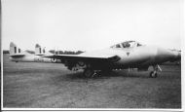](http://www.spanglefish.com/dehavillandvampire/pictures/big/Vamp.T.11%20XD425%205FTS%206.60%20Roger%20Lindsay%20.jpg)At 5 FTS June 1960

**To 8 FTS Swinderby 12/04/1962**

**To 19 MU St Athan 05/11/1963 for storage until declared non-effective on 05/07/1967**

**Sold 30/11/1967 to Hawker Siddeley**

**At Poynton 15/3/72 dismantled in storage**

**To Stranraer Academy 13/02/1973**

**To Dumfries & Galloway Aviation Group (established as a Museum in 1977), Tinwald Downs, 09/10/1976**

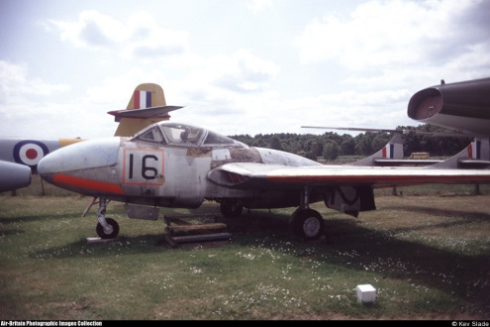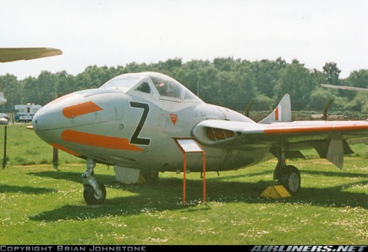

At Tinwald Downs June 1992 At Tinwald Downs May 1997

**The wings from this aircraft later went to XD547 with the fuselage going to Millom**

**To RAF Millom Aviation and Military Museum, Haverigg, Cumbria, 01/1995**

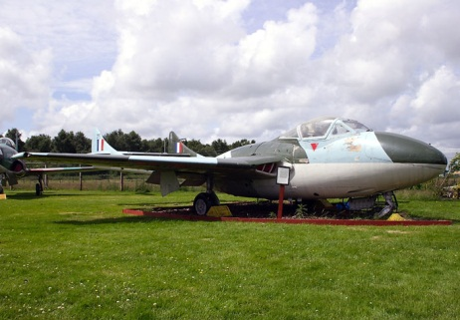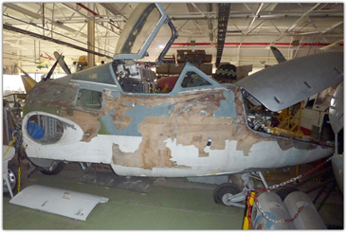

At Millom Jul 2005 At Millom 2011

**Sold at auction 01/2011 to private owner (Neil McCarthy) from Seaton Burn, North Tyneside**

[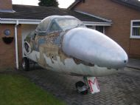](http://www.spanglefish.com/dehavillandvampire/pictures/big/IMGP0673.jpg)[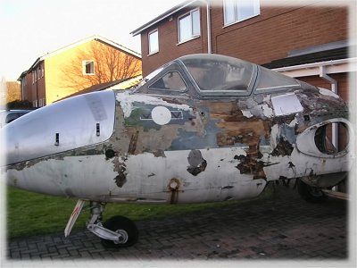](http://www.spit4hire.com/uploads/1/5/7/2/15726540/4228985_orig.jpg)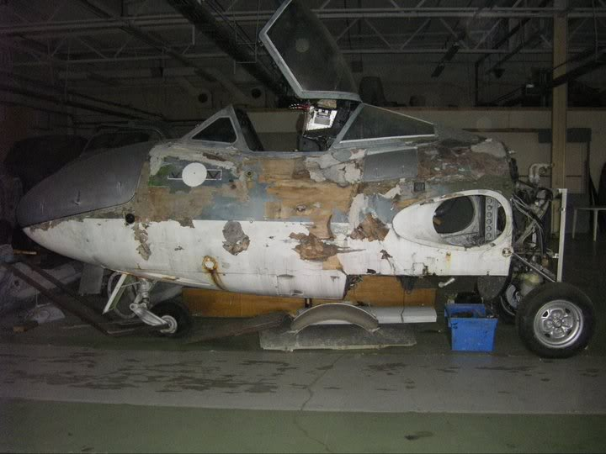

At Seaton Burn 2011 pre restoration

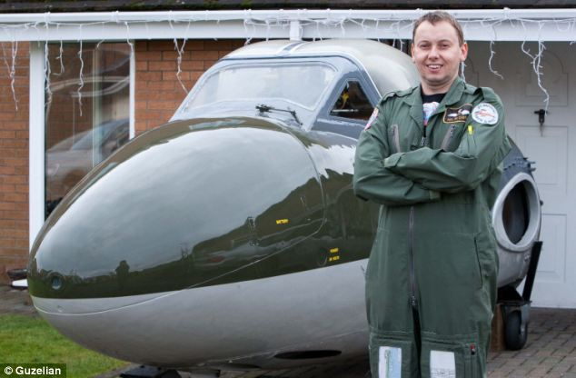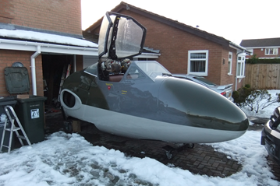[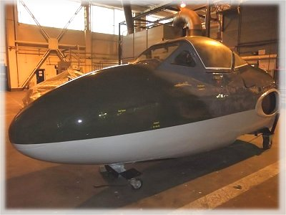](http://www.spit4hire.com/uploads/1/5/7/2/15726540/1358155_orig.jpg)

At Seaton Burn 2013 post restoration. Composite repair work by North Eastern Composites and repaint by SERCO at RAF Leeming.

**Delivered to Morayvia 20 April 2013**

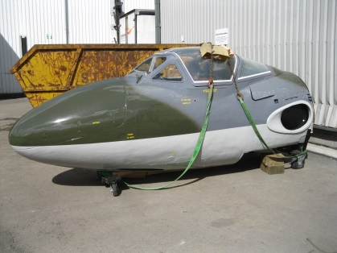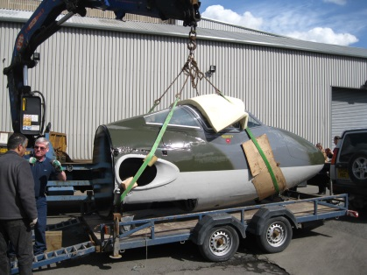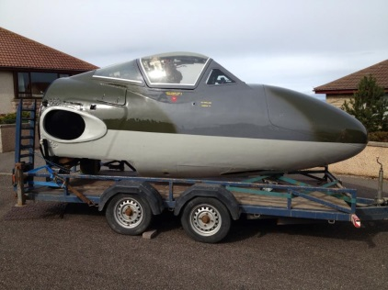

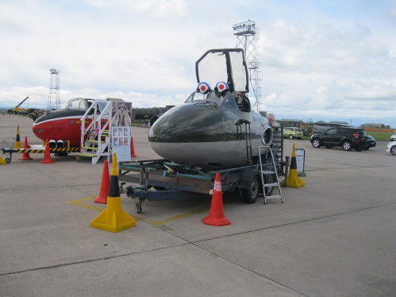 Lossiemouth Families and Friends Day 22 June 2013