History of Westland Wessex HU5 XT466 (c/n WA288)
15/10/65 First flight flown by Mr DAS Colvin
19/10/65 Delivered to RN and held by HHU RNAY Fleetlands
18/11/65 845 Sqn coded DB
20/12/65 Stbd engine fire warning during an engine ground run (Lt A MacGregor)
01/04/68 Flotation gear inflated prior to take-off on HMS Bulwark (Lt LK Eames RM & LREM E Keen)
16/05/68 Hydraulic failure, precautionary landing Culdrose (Lt RDP Henderson, Sqn Ldr RM Todd + 5 pax)
14/07/68 Crane on HMS Bulwark flight deck at Wilhemshaven struck nose door
02/08/68 RNAY Fleetlands
06/11/68 845 Sqn coded DB/DA
25/11/69 Tail pylon-fold warning in flight, landed at RAF Valley (Capt WR Spicer USMC & LREM Moorehead)
30/01/70 RNAY Fleetlands
23/04/70 845 Sqn coded DA, DB, (Y) DA
23/09/70 Underslung trailer fell 200ft from underslung hook in hover, Lefkonico Range, Cyprus (Lt RE Graves)
28/09/70 Damaged whilst landing on uneven ground, Goshi Trouli Range, Cyprus (Lt RE Graves)
19/05/71 Port engine ran down prior to take-off, Woodbury Common, Exmouth (Lt RG Evans RM)
04/09/71 Flotation bags inflated in hover alongside HMS Bulwark off Plymouth (L/C JT Rawlins/Lt RF Shercliff)
15/10/71 Underslung Land Rover dragged sideways along ground, Turkey (Lt TJ Yarker)
16/02/72 Main rotor blades hit tree at landing site at Vieques airfield Puerto Rico (Lt Cdr RF Shercliff)
18/02/72 Stbd engine failure after take-off, Roosevelt Roads (Fg Off D Whatling RAF & Lt R Money)
20/09/72 HMS Albion, co-pilots sliding window lost in flight (Lt PR Calderly)
24/11/72 Noted on HMS Albion, 845 Sqn coded D
23/01/73 Stbd engine throttle problem (Lt M Heger FN)
13/06/73 RNAY Fleetlands for repair
08/05/74 NASU Yeovilton
00/06/74 848 Sqn coded VL/B
21/09/74 Noted at Yeovilton Airshow coded VL/B
00/01/75 NASU Yeovilton
28/10/75 848 Sqn coded VL/B
00/07/76 RNAY Wroughton
09/12/76 RNAY Fleetlands long term storage
23/02/79 NATIU Lee-on-Solent
01/08/79 771 Sqn Culdrose coded 528/CU
02/03/81 RNAY Fleetlands
27/04/81 771 Sqn Culdrose coded 528/CU
26/06/81 Noted at World Helicopter Championship coded 528/CU of 771 Sqn at Culdrose
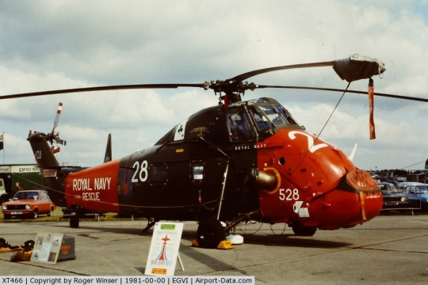
29/03/82 771 Sqn Culdrose coded 528/CU
05/05/82 Transferred to reformed 847 Sqn, delivered by air to Yeovilton on 06/05/82 uncoded
07/05/82 Allocated to 847 Sqn, B Flt, coded XV
13/05/82 Flown from Yeovilton to HMS Raleigh, Torpoint and embarked on mv Atlantic Causeway in Plymouth Sound (one of 20 Wessex HU5s)
14/05/82 Sailed on MV Atlantic Causeway to Falkland Is, arrived Ascension Is 22/05/82, anchored San Carlos
Water 01/06/82
01/06/82 Disembarked to the FOB at Port San Carlos settlement, later operated from Teal Inlet, Fitzroy and
elsewhere, before moving to Navy Point 25/06/82
25/06/82 Transferred from 847 Sqn to 845 Sqn Falkland Islands Detachment at Navy Point till 27/09/82
06/11/82 Embarked onto MV Astronomer off Port Stanley and sailed for UK circa 14/11/82
03/12/82 Arrived Devonport, still coded XV and offloaded 04/12/82
08/12/82 Delivered by road to RNAY Wroughton where it was transferred from 845 Sqn to RNAY Wroughton
03/02/87 Delivered to 2 SofTT RAF Cosford as 8921M
15/04/91 Delivered to by road to Duke of Wellington’s Regiment, Weeton Barracks, Preston, as A2617 for use
as a de-emplaning trainer
16/05/97 By road to AESS (Air Engineering & Survival School), HMS Sultan, Gosport as GIA helicopter
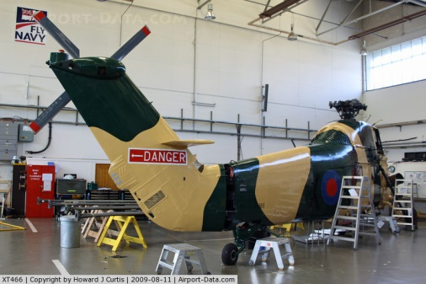
25/10/09 Noted onshore at Liverpool with HMS Illustrious for Fly Navy 100 Celebrations coded “X-V”
11/09 to 08/15 Whittington Barracks, Lichfield, Staffs as Gate Guardian
02/09/11 Noted at Whittington Barracks
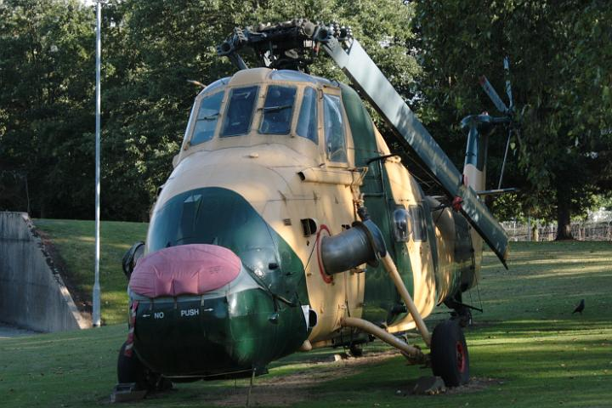
08/15 Everett Aero, Sproughton, Suffolk
02/16 Private owner, stored at Kemble Airport, Glos
09/17 Private owner, Robert Pountney, loaned to Morayvia at Kinloss, stored at Spey Bay Moray
04/05/17 Transported to Morayvia
12/09/18 Visited by the Duke of York after having been repainted in RN SAR colours and named “Duke of York”
