EE Lightning F1A XM169, c/n 95056
(Contract 6/acft/15445)

16/08/60 First flight by RP Beamont (also first flight of a Lightning Mk F1A)
Retained by EE for flight refuelling trials, this was the first Lightning fitted with an AAR probe
22/07/61 A Sqn A&AEE Boscombe Down
18/09/61 Warton
19/07/62 A&AEE for TACAN trials
18/08/62 Warton
25/11/62 Released from trials having completed 223 trial flights and 121.13 flying hours
14/10/64 Delivered to 111 Sqn RAF Wattisham coded B
18/02/65 56 Sqn RAF Wattisham
12/04/65 33 MU RAF Lyneham for storage
09/08/66 60MU RAF Leconfield for storage and modifications embodiment
00/07/67 Transferred to 60 MU Storage and Handling Flt as Immediate Readiness Reserve (IRR)
23/01/68 RAF Binbrook Target Facilities Flight (TFF) coded X
00/06/70 5 Sqn RAF Binbrook coded X
01/10/72 RAF Binbrook TFF
03/09/73 23 Sqn TFF RAF Leuchars coded W
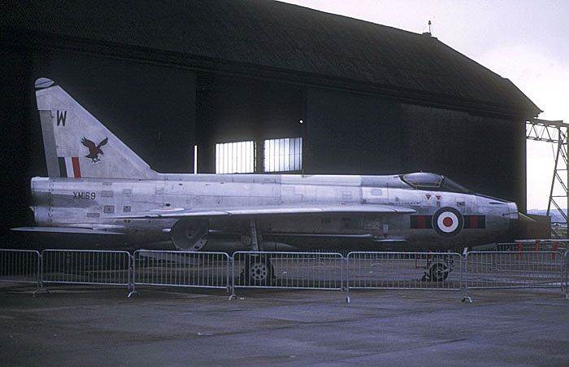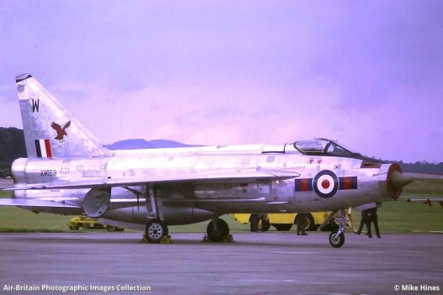
03/01/74 Final flight with 812 airframe hours
13/06/74 Decoy duties and BDRF at Leuchars as 8422M
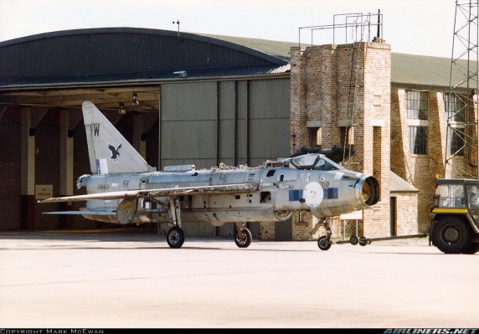
16/05/89 Sold as scrap to Calverts Ltd of Thirsk. Nose section purchased by K Ward at Chop Gate
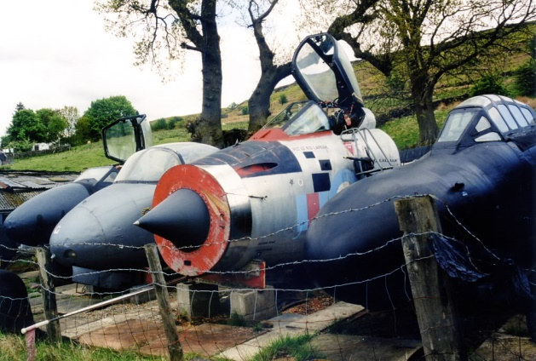
00/06/04 Nose section to Highland Aviation Museum, Inverness (On loan from K Ward)
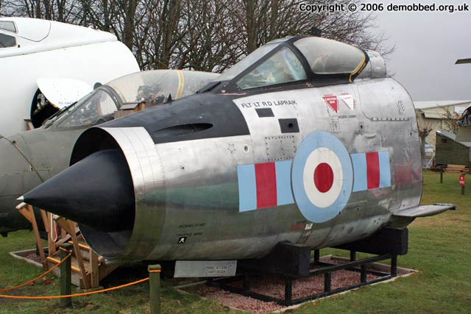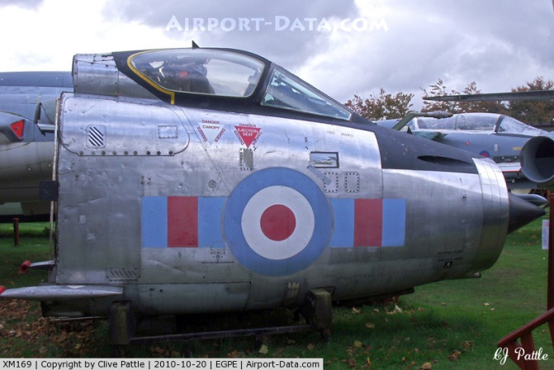
18/12/17 Nose section to Morayvia, Kinloss (On loan from K Ward)

Lightning F.1A  28 built | Single-seat fighter, delivered in 1961. Featured Avon 210R engines, an inflight refuelling probe and UHF Radio.
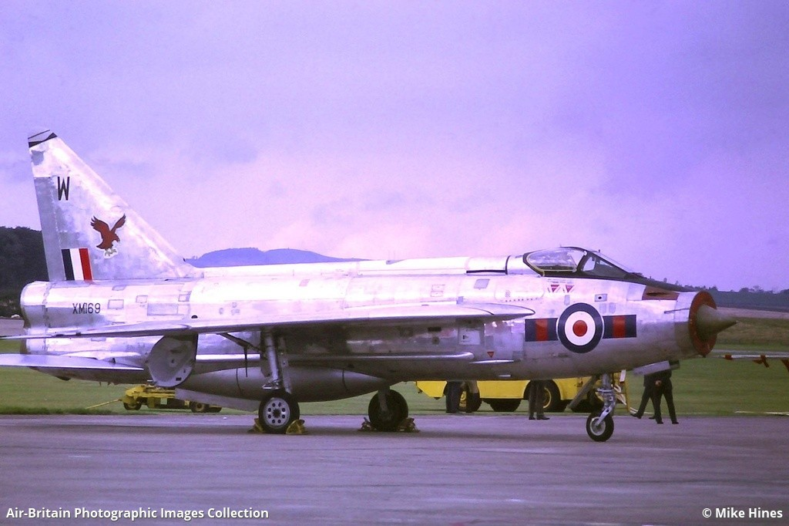

XM169 came from Leuchars where she had ended her life as a decoy airframe. While her exterior is looking in good condition, the cockpit interior is absolutely immaculate - and entirely complete. The previous owner, Ken Ward, had rigged up a small hand operated hydraulic pump which raises and lowers the canopy, after a brush with death in the past when the canopy closed on him, cutting off his air supply while he was working in the cockpit. Thankfully he managed to move himself around and use his legs to push the (very heavy) canopy open slightly to allow some airflow until he was rescued.
30 ser nos XM169-XM192 (24) and XM213-XM218 (6) but only 28 built, XM217 and XM218 not built

References - Magazines
- The Aeroplane, 13th July 1961: Lightning - full article including cutaway drawing.
- Aeroplane Monthly, August 1988: A Flash of Silver - part 1 of an article on the Lightning by Roland Beamont (and therefore required reading of course!). This part covers flying the SB.5, P.1 protoypes and development aircraft.
- Aircraft Illustrated, April 1970: Target Practice Lightnings by Roger Levy. Very short article on Lightning Target Facilities Flights with some monochrome pictures of the F.1s then used by the various TFFs.
- Aircraft Illustrated, August 1974: Lightnings at Gütersloh - photo report on 19 and 92 Sqn's F.2As, some in colour.
- Aircraft Illustrated, June 1975: A Look at the Lightning by Philip J. R. Moyes. A rundown of the variants with lots of, unfortunately small, monochrome pictures, but one nice full-page colour shot of a T.5, T.4 and F.1A in formation.
- Aircraft Illustrated, July 1988: Lightning Flashes - centrespread colour picture of F.6 XS923 plus a Squadron Print of F.6 XS903.
- Aircraft Illustrated, March 1996: Harnessing Lightning - article on Tony Hull's restoration of T.5 XS452 to running condition with some good pictures (not just of XS452). XS452 is now in South Africa... to fly!
- AIR Enthusiast, June 1972 - Arabian Fledgling - article on the Royal Saudi Air Force including a fair bit on their Lightnings and some pictures of 53-693, 53-674 and 53-669.
- Air Extra number 14 by Ian Allen - The BAC Lightning - not seen it myself.
- Air Forces Monthly, September 1988: Last, Last Lightning Show - tribute, with some great pictures.
- AIR Pictorial and Air Reserve Gazette, December 1954: FD.2 and P.1 Technical Analysis by James Hay Stevens - 'deductions of a competent engineer from careful study of official photographs' - plus some scale plans of the P.1 drawn based on photos - security was tight in those days!
- AIR Pictorial and Air Reserve Gazette, August 1957: P.1B by Roy Cross - centre spread with a few monochrome pictures and a beautifully drawn 3-view.
- AIR Pictorial, January 1972: part 1 of Lightning in RAF Service (covering F.1, F.2, F.3 and T.4). With several black and white pictures and camouflage scheme 3-view.
- AIR Pictorial, February 1972: part 2 of Lightning in RAF Service (covering T.5, F.6 and F.2A) and Lightning Ride - an account from Roger Levy of his flight in T.5 XS422.
- AIR Pictorial, February 1976: Lightning Pilot by Dagmar Heller - well-rounded article about a typical Lightning sortie.
- AIR Pictorial, January 1987: Lightning Flight - Malcolm English gets a go in a T.5. Lucky man!
- AIR Pictorial, July 1988: Last Lightning Sortie - article on a flight with 111 Sqn shortly before retirement, some good monochrome pictures and a single colour one (inside the back cover).
- AIR Pictorial, June 1998: Lightning and the Unbuilt Projects; an article from Tony Buttler on the various proposals for advanced Lightning variants. Makes interesting reading! Several diagrams and a few pictures too.
- Flight International, September 1968: Multi-mission Lightning - not seen it myself.
- Jets, Summer 2000: Flight Test: Lightning F.6 vs Tornado F.3 by Ian Black. Good article on flying both beasts - no guesses as to which wins when it comes to flying for fun!
- Modelaid International number 4: The Lightning - article on the Lightning with three colour profiles (F.3, F.2A and F.6), development and service history, several monochrome pictures, a cardboard fold-together cockpit for use in a 1/72 model and scale plans with coverage of the P.1A, P.1B, F.1A, F.2A, F.3, T.4, T.5 and F.6 (side views only for all but F.6) plus a few monochrome detail pictures. Worth getting hold of if you're a modeller and if you can find it!
- Osprey Magazine 1972: EE/BAC Lightning in RAF & foreign service - not seen it myself.
- Scale Aircraft Modelling, volume 22 number 3, May 2000: Aircraft in Detail: EE (BAC) Lightning part 1: Development and Type Differences by Fred Martin. Lots of colour photos and profile drawings, well worth getting.
- Scale Aircraft Modelling, volume 22 number 4, June 2000: Aircraft in Detail: EE (BAC) Lightning part 2: Operating Units by Fred Martin. More colour photos and a rundown of the squadrons that flew Lightnings with notes on colour schemes etc.
- Scale Aviation Modeller, volume 1 issue 9, September 1995: English Electric Lightning; service history, many good photos (though most without any description or credit), number of camouflage scheme side views, plus a good roundup of available Lightning model kits, accessories and decal sheets.
- Scale Aviation Modeller, volume 4 issue 2, February 1998: Very Heavy Metal - the Lightning F.2A/F.6; history, some nice black and white photos of Lightnings at Malta, scale plans of the F.6 and ten gorgeous colour profiles.
- Scale Modelling International, January 1992: part 1 of Echelon's Lightnings - article on building the Echelon vacform kit.
- Scale Modelling International, April 1992: part 2 of Echelon's Lightnings, with colour detail pictures.
- Scale Modelling International, May 1992: part 3 of Echelon's Lightnings.
- Scale Modelling International, July 1993: Triple Lightning Strike - article on building the Aeroclub 1/48 mixed media kits.
- Take Off numbers 18 and 19: Lightnings of the Royal Air Force - run down of colour schemes and squadrons with lots of pictures.
- Warplane part 20: Lightning - bolt from the blue - good article with history, pictures, specs, variants, superb foldout poster and cutaway drawing. Recommended.

Credits

