Hawker Hunter F5 WN957 (Armstrong Siddeley Sapphire Engine)
WN957 (Cen Fuse c/n S4/U/2944) was the fourth prototype F5 off the Sir WG Armstrong-Whitworth Aircraft Co Ltd production line in Coventry. One production batch of 150 Hunter F5s was manufactured by Armstrong Whitworth at Coventry. Second part of Contract No SP/6/6315/CB.7a.
10 Nov 1954 – Aircraft build completed and waiting collection.
17 Nov 1954 - Allocated to RAE Farnborough for Fighter Armament Development.
24 Nov 1954 - Delivered from Hawker’s factory in Dunsfold, to RAE Farnborough, unfortunately she arrived unserviceable following a CAT 3 incident, so the RAE declined to accept her.
12 Feb 1955 – Formally accepted by RAE Farnborough and was used by the RAE for Fighter Armament Development and for experiments on the USAF Low Altitude Bombing System (LABS) Computer. Following this, WN957 was struck off charge 20 Feb 1957 and returned to the RAF in Apr 1957.
21 Feb 1957- Allocated to RAF St Athan as a Ground Instructional (GI) Airframe, 7407M.
2 Apr 1957 - Delivered to No 4 School of Technical Training, RAF St Athan.
16 Sep 1961 – Noted at the RAF St Athan Battle of Britain Open Day in the 4 S of TT hangar.
By 1967 – Cockpit at 60 MU, RAF Leconfield, Yorks.
Circa May 1967 – Entry from 229 OCU Chivenor ORB “The cockpit of 7047M was transported from RAF Leconfield to RAF Chivenor by Chf Tech Wooley accompanied by a small working party. On arrival at Chivenor this team spent one week from the 1-8 May modifying the cockpit iaw an instruction issued by Sqn Ldr Norris, the Chief Ground Instructor. The sectioned cockpit will in future be used to instruct and check student pilots on their ejection drills.” This action was carried out so that students could fully view the workings and rigging of the Martin Baker Mk2H ejection seat, the cockpit was cut off just forward of the rear bulkhead. The nose was also cut off just forward of the front cockpit bulkhead. It is believed that WN957 continued in this role until Chivenor closed in 1974.
Jul 1967 – WN957 fuselage noted at the RAF St Athan dump.
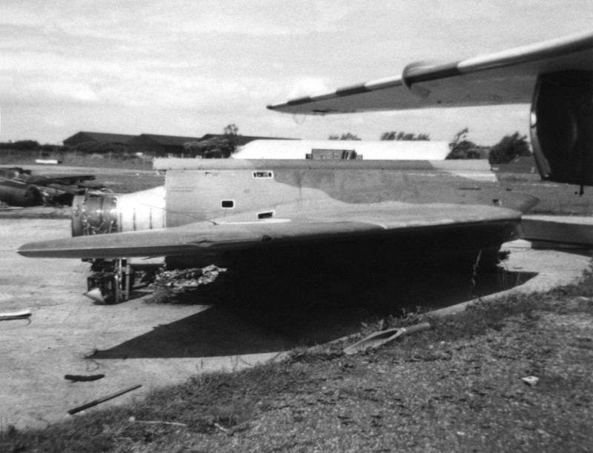
Circa 1974 - Transferred to an Air Training Corps (ATC) unit in North Weald, Essex.
Late 1970s to 1989 - Disposed of and bought by Bill Miles at North Weald.
1989 - Storage at RAF Stafford and latterly used in the Ejection Seat Servicing Bay.
Feb 1995 – Transferred to 2445 Sqn, Air Training Corps at Llanbedr, North Wales.
1998 – Private owner, Roy Jerman of Maes Artro Village Museum of Bygone Days, Llanbedr, North Wales.
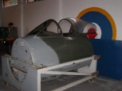
The Maes Artro Heritage Museum is no longer open to the public; it closed down several years ago. There is now a holiday park on the site, although some of the museum buildings are currently still standing, although derelict. Historically, the site was connected with RAF Llanbedr (1941- 2004). It served as a training camp (RAF's No. 12 Fighter Gunnery School (opened in 1943)) and a place of rest and recuperation during World War II, for active squadrons. The museum once described the history of RAF Llanbedr, along with a section showing rural life prior to the introduction of electricity, and it also housed a recreated Welsh village street circa 1900.
Sep 2002 – Private owner, Powys
Sep 2006 – Private owner, Dave Taylor, South Moulton, North Devon
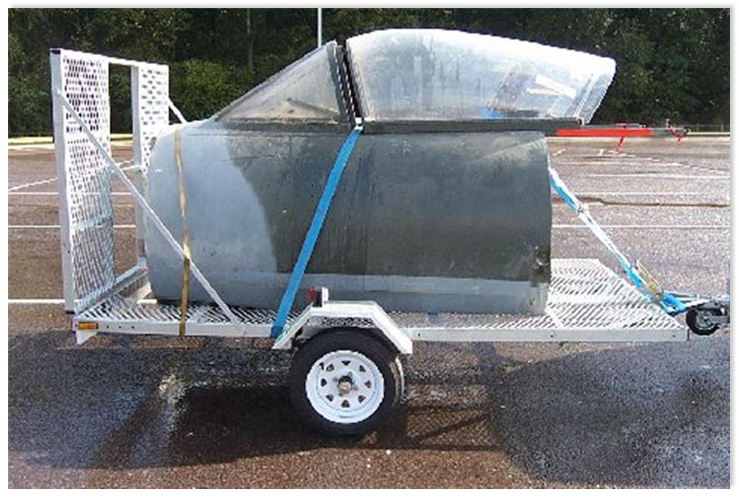
Jun 2007 – Private owner, Michael Rolfe, Stockport, Greater Manchester. Michael rebuilt the rear cockpit bulkhead (removed when she became an ejection seat procedures trainer), and replaced the missing nose cone, along with many other missing components. The 'new build' rear cockpit bulkhead is a faithful representation of the real thing, with the measurements taken from Hunter F6, XE584.
2008 - WN957 seen below at Cockpitfest, Newark
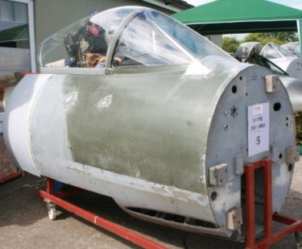
2009 - The nose of Dutch Air Force Hunter F6, N-202, was procured by Michael Rolfe in early 2009. This nose was carefully de-riveted from N-202 and was grafted onto WN957 once the corrosion had been removed and treated.
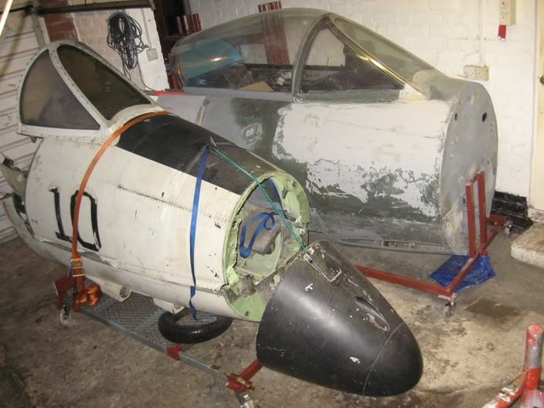
May 2016 – Private owners, Bob Pountney & Chris Herbert, Moray. Bought as seen in the picture below.
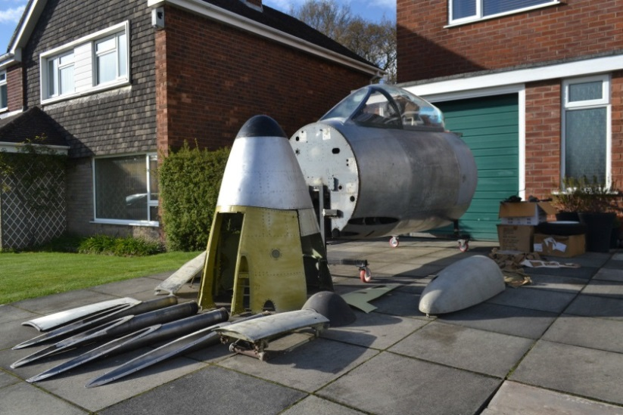
June 2016 - On loan to Morayvia Sci-Tech Experience Project at Kinloss Moray, where the cockpit rebuild will be completed and put on display.
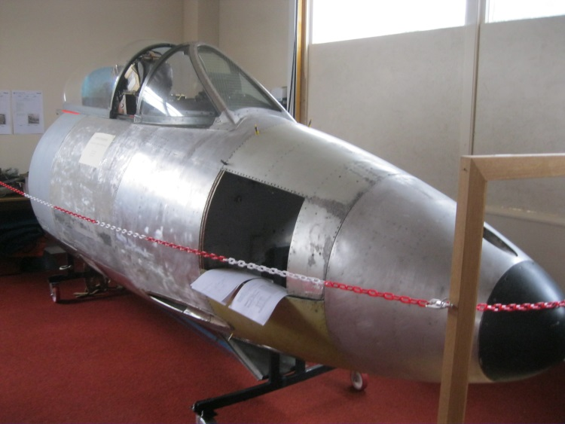
There is believed to be only one Hunter F5 cockpit (WN957) and two complete Hunter F5 aircraft (WP185, private owner and WP190, Tangmere Military Aviation Museum, in existence.

