03/10/1963 | Awaiting collection from manufacturer
03/10/1963 | Delivered to No.27 MU Shawbury
10/01/1964 | 2 FTS Syerston coded ‘28’ & ‘36’
10/07/1968 | No.27 MU Shawbury
18/10/1968 | No.5 MU Kemble
01/11/1968 | No.27 MU Shawbury
28/01/1969 | 3 FTS Leeming coded ‘47’
24/11/1970 | Central Air Traffic Control School, Shawbury coded ‘O’
28/02/1972 | College of Air Warfare, Manby coded ‘18’
06/12/1973 | School of Refresher Flying, Leeming coded ‘71’
25/02/1974 | No.5 MU Kemble
26/02/1975 | School of Refresher Flying, Leeming coded ‘71’
24/02/1977 | No.1 SofTT Halton for ground instructional use as 8514M
06/1993 | Tendered
27/10/1993 | Transported to Phoenix Aviation, Bruntingthorpe
03/11/1993 | To University of Salford, Manchester
15/07/1999 | To Bruntingthorpe
08/1999 | Reduced to nose section and transported to Solihull
2000 | To Stamford
18/06/2005  11/2012 | To Highland Aviation Museum, Inverness for display  To Morayvia on loan from owner  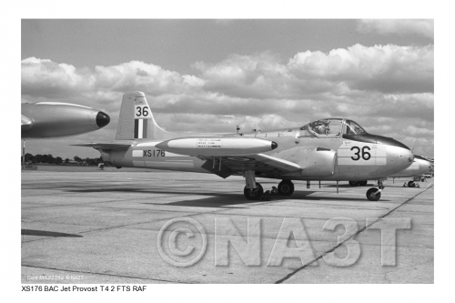  XS176 at 2FTS Syerston 5/8/67

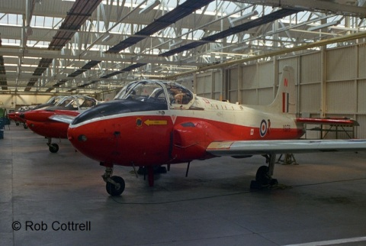XS176 at 1 S of TT (8514M)
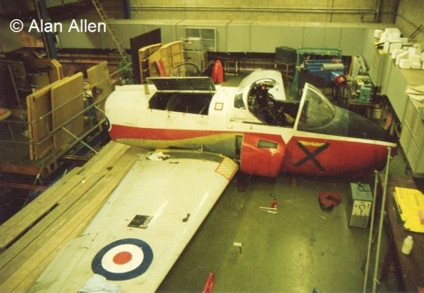XS176 at Salford University
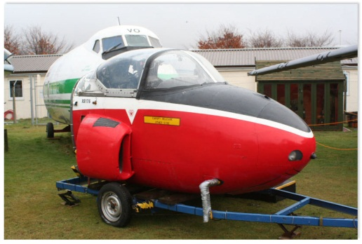XS176 (Nose) at Highland Aviation Museum

