Westland Whirlwind HAR 10 XJ723 c/n WA94

03/10/55 f/f as a WS-55 Whirlwind HAR 2 with a Pratt & Whitney engine
14/10/55 a/w c/n WA94
00/10/55 d/d to Westland Helicopters
00/00/55 155 Sqn Kuala Lumpur, Malaya with dets at Seletar and Kluang. (03/09/59 - 155 Sqn disbanded and joined with 194 Sqn to form 110 Sqn)
03/09/59 110 Sqn Butterworth, Malaya with a detachmant at Seletar, Singapore
05/10/60 Transferred to Westland’s Old Mixon factory at Weston Super Mare for conversion to HAR 10 standard with a Gnome engine
03/04/62 Return to RAF service
04/04/62 228 Sqn C Flt Leuchars? (01/09/64 – 228 Sqn renumbered 202 Sqn)
01/09/64 202 Sqn Leconfield

27/12/65 202 Sqn RAF Leconfield, took part in rescue operation at Sea Gem oil rig disaster. Sergeant John Reeson, 32, the RAF winchman, was awarded the George Medal. The navigator, Flight Lieutenant John Hill, 35, received the Air Force Cross and the pilot, Sergeant Leon Smith, 24, got the Queen's Commendation
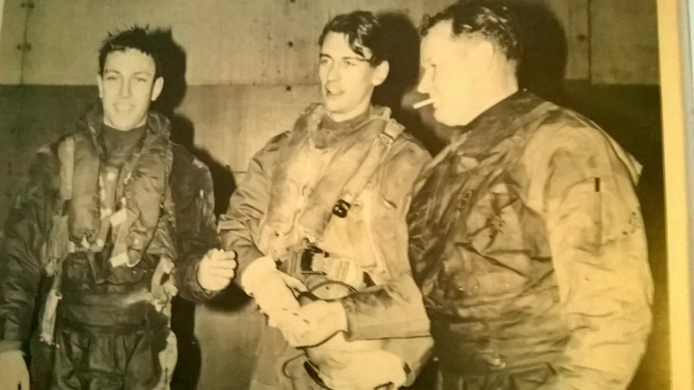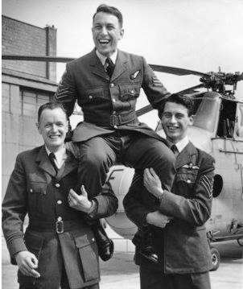

13/06/67 Noted on strength of A Flight 202 Sqn at Leconfield (Yorkshire Air News June 1967)
12/06/69 Noted at Thorney Island belonging to 202 Sqn
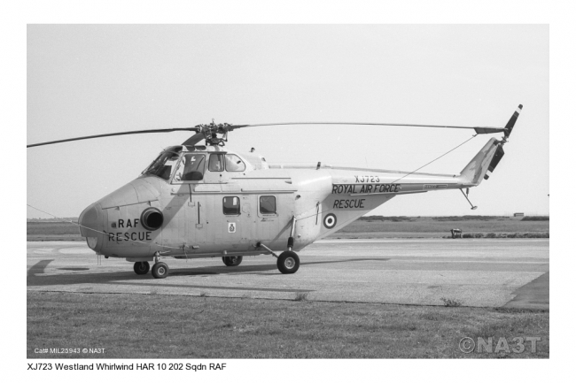
19/09/70 Noted at Leuchars belonging to C Flight 202 Sqn
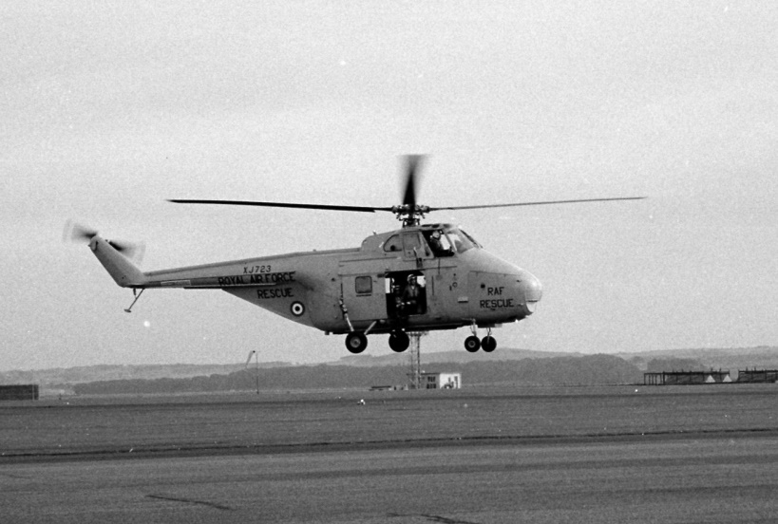
00/09/73 Noted at C Flt Leuchars for Bof B Display
24/10/74 Noted at Boulmer
25/05/75 Reported flown on an air test at 202 Sqn Leconfield
31/05/75 Reported flown at 202 Sqn Leconfield
02/11/76 to RNAY Wroughton for storage
30/07/77 Used as a hangar display helicopter at the Silver Jubilee RAF Review at RAF Finningley
17/03/78 Noted in storage at RNAS Culdrose with XD182 and XJ724
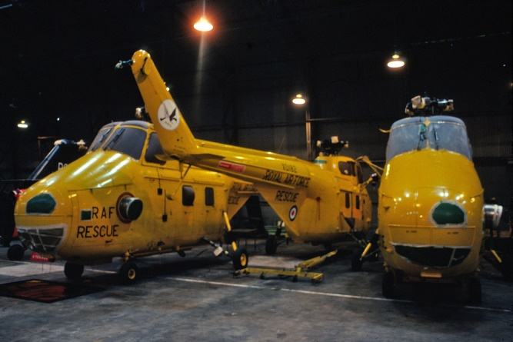

29/3/79 Sold to Offshore Petroleum Industry Training Board (OPITB) at Montrose for Ground Instruction (SAR yellow scheme)
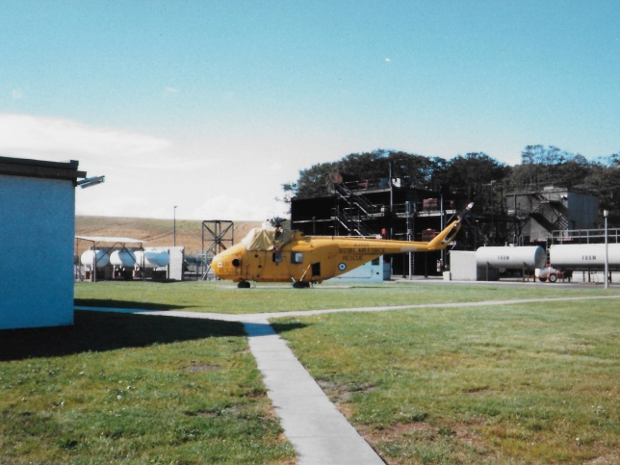

1/6/89 Donated to 2288 Sqn ATC, Montrose, used as a gate guard (later hand painted in grey/green camo scheme)

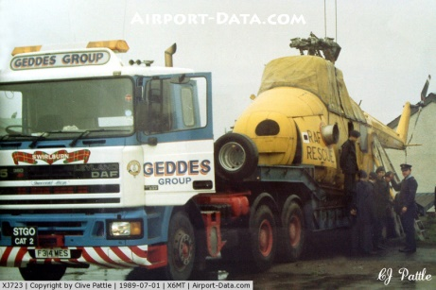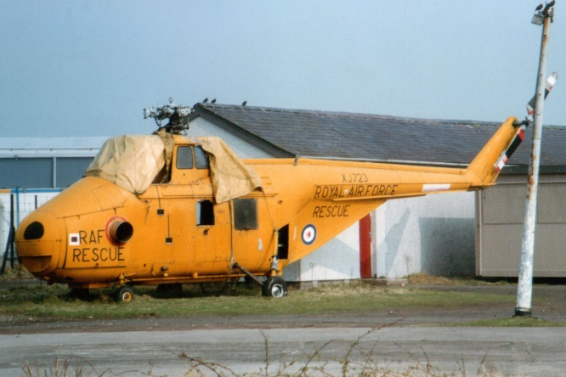Montrose 1992

00/05/93 loaned to Montrose Aerodrome Museum Society for display
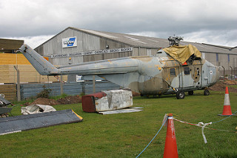Montrose 2005
00/12/2006 Sold by Montrose to Newcastle University for restoration as an instructional airframe
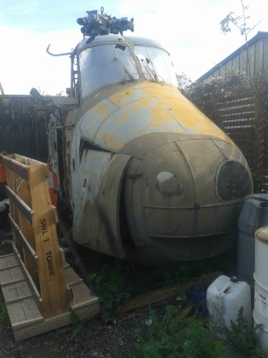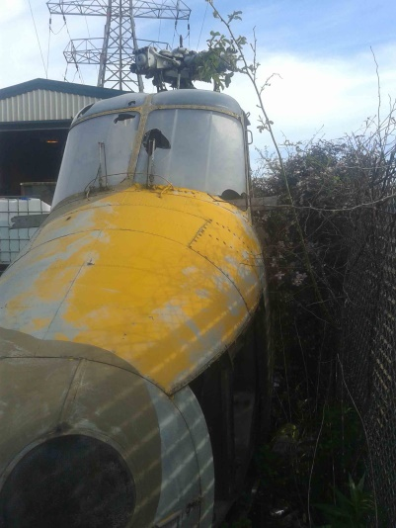
01/07/2017 Gifted to Morayvia by Brian Dixon and transported from Newcastle to Spey Bay 04/08/17
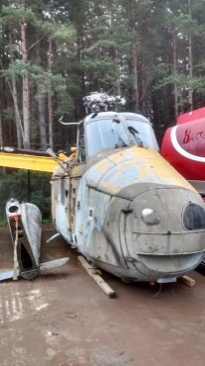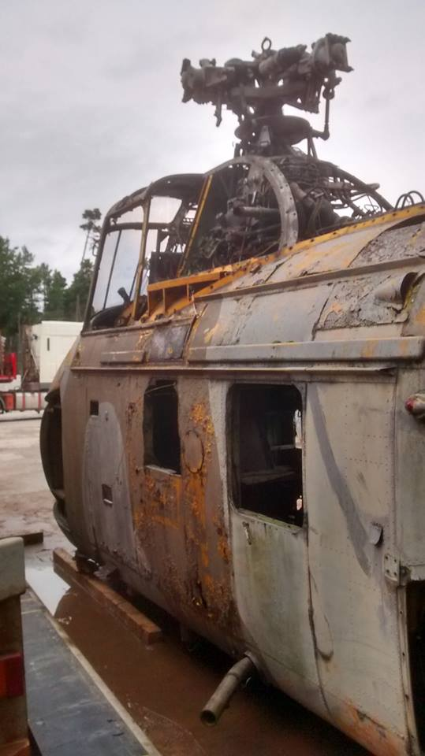
26/10/17 Delivered to Morayvia from Spey Bay
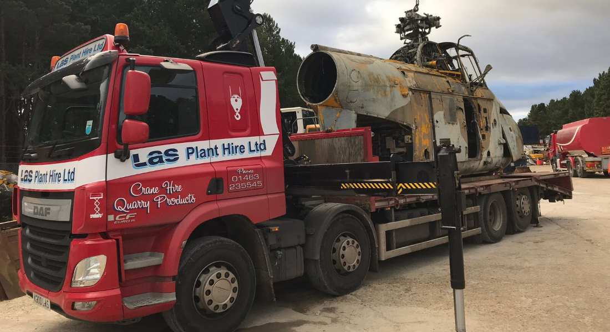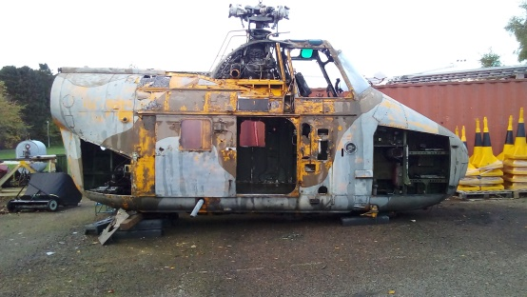
30/01/18 Undercarriage oleos and wheels refitted
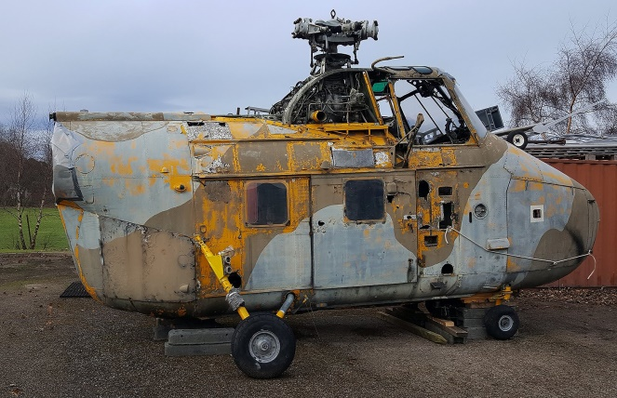
11/11/18 Main Rotor Gearbox removed prior to start of aircraft reburbishment
